**Name: Ankur Sehrawat**

**Roll Number: R171218023**

**SAP ID: 500069044**

**Lab: 1**

**Installation of Jenkins and Execution of a simple job in Jenkins**

**Steps**

**1.**  Download Jenkins for whatever platform you are working.

**2.** After download open command prompt and go to location where bin is stored for Jenkins.

**3.** Run command java -jar jenkins.war.

**4.** login to jenkins.

**5.** Select “New Item” and select maven project.

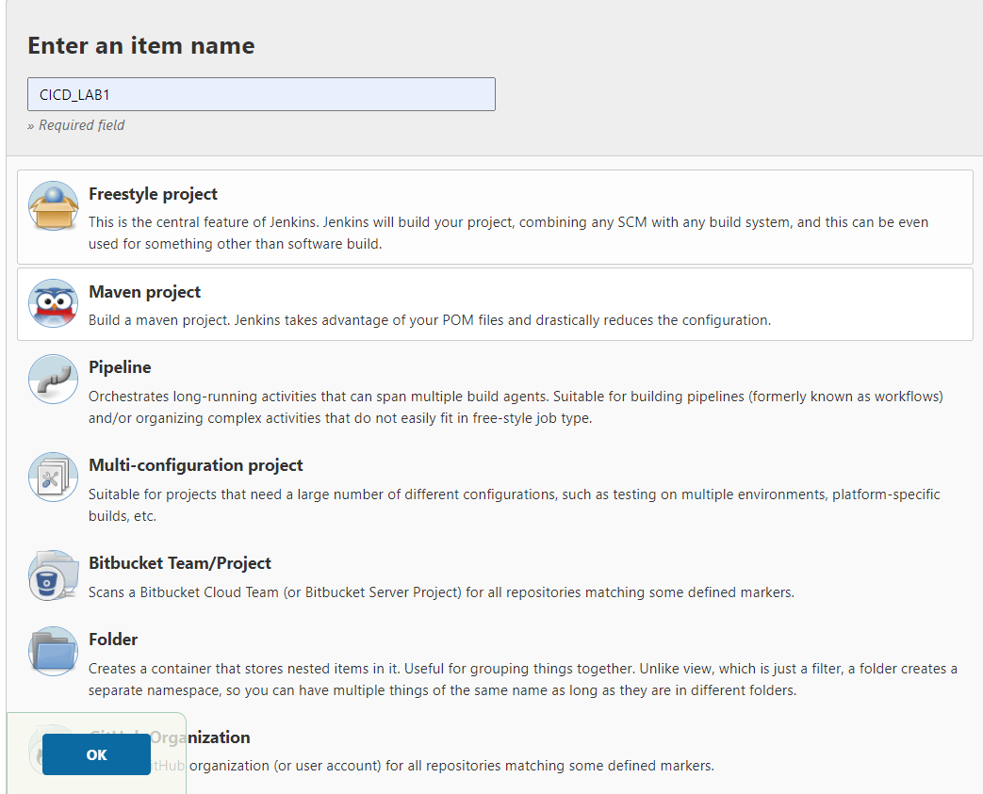

**6.** Run a simple task in jenkins.

**7.** Build the task.

